Instructions for poster presenters

All posters will be presented in a “paper” format.
Posters will be available in Amazonas 3 and 4 during the whole congress. There is no specific time for poster session.

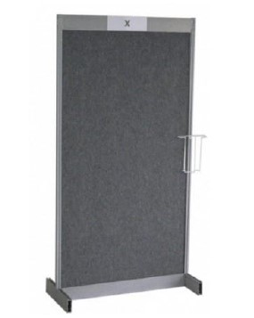

Technical Instructions
- Size of the construction is 200 cm (height) x 100 cm (width).
- The maximum size of the poster should be 180 cm (height) × 97 cm (width) but to keep the poster legible, we recommend a maximum size of 119cm (height) × 84cm (width) or A0 format.
- Fixing material will be available in the Posters Area.
- The poster boards will be numbered according to the Poster code given by the organizers.
- Posters must be prepared in Portrait style.

Poster Mounting and Removal Times
- Posters should be mounted from 13:00 on 3rd June.
- All Posters will be removed and discarded if not removed by 16:00 on 5th June.

All authors are responsible for mounting and demounting their posters on time.

